Pedestrian Attribute Recognition on the UPAR Challenge 2027 (Track 1)
Computer Vision, Assignment 2
Adina Faraz (23K-0008) and Syed Muneeb Ur Rehman (23K-0038)

1. Task and Approach
We worked on Track 1 of the UPAR Challenge 2027, which is part of the Real-World Surveillance workshop at WACV 2027. The task is pedestrian attribute recognition: given a cropped image of a person, predict 40 yes/no attributes such as age, gender, hair length, clothes colour and type, and accessories like bag, hat and glasses. The test images come from a domain that is not in the training data, so the model has to work on new camera conditions.
Our approach is simple. We took a ConvNeXt-Small model that was already trained on ImageNet and fine-tuned it on the UPAR training data. We added a few things that help with rare attributes (a weighted loss, strong augmentation and a separate threshold for each attribute) and then submitted the model to the Codabench challenge as a code submission.

2. Data and Evaluation
The training data joins three public datasets under one common list of 40 attributes: PA-100K (79,001 images), Market1501 (10,000) and PETA (8,668), which is 97,669 images in total. The validation set has 33,407 images (Market1501 16,458, PA-100K 9,986, PETA 6,963). The hidden test set is not given to us, we only get its score from the platform.
The challenge uses three numbers. mA is the average, over all attributes, of the true positive rate and the true negative rate. Instance F1 is the F1 score of each image, averaged over all images. Avg is the harmonic mean of these two and it is the ranking score. When the test set has images from several datasets, each dataset is scored alone and the results are averaged. We used the same rule on our validation set.

3. Methodology
- Model: ConvNeXt-Small from torchvision, pretrained on ImageNet. We replaced the last layer with 40 outputs (one sigmoid per attribute). Input size is 256 x 128.
- Training: AdamW optimizer, learning rate 1e-4 with a one-cycle schedule, batch size 48, 10 epochs, mixed precision (bf16) and an exponential moving average of the weights. We trained on one RTX 3080 Ti laptop GPU (16 GB).
- Loss: binary cross-entropy. Positive examples of rare attributes get a larger weight (square root of the negative to positive ratio, limited between 1 and 8). We also used light label smoothing (0.02).
- Augmentation: random down-scaling to copy low-resolution images, colour jitter, blur, small rotation, shift and scale, horizontal flip, and random erasing.
- Test time: we average the prediction of the image and its mirror image.
- Thresholds: instead of 0.5, we picked one threshold per attribute on the validation set, to get the best Avg. We put the threshold inside the model output, so the platform rule (above 0.5 means present) still works.
- Submission: this challenge needs code, not a prediction file. We packed run.py and the weights (fp16, about 91 MB) into one zip. The platform runs it on an A10 GPU with a 5 minute limit and only PyTorch and torchvision installed, so we used torchvision's ConvNeXt and batch inference (about 208 images per second on our laptop).
- Second run: the same model with a larger input (320 x 160, 8 epochs), to check if more resolution helps with small things like glasses and bags.

4. Results
Our first model (Run 1) gets Avg 87.69 on the validation set and 0.7565 on the hidden test set. Table 1 shows the validation scores (average over the three datasets) and Table 2 shows the test scores from the Codabench leaderboard. The attribute prior is the trivial baseline from the starter kit: every image gets the average rate of each attribute, so it never looks at the picture.
Table 1. Validation set (scores out of 100)
Method | mA | F1 | Avg
Attribute prior (no model) | 52.50 | 60.16 | 55.98
Run 1, threshold 0.5 | 84.96 | 87.98 | 86.45
Run 1, tuned thresholds | 88.12 | 87.26 | 87.69
Run 2 (320 x 160), threshold 0.5 | 85.58 | 87.70 | 86.62
Run 2 (320 x 160), tuned thresholds | 88.24 | 87.21 | 87.73
Per dataset (Run 1, tuned thresholds), Avg is 87.33 on Market1501, 86.09 on PA-100K and 89.64 on PETA. The prior gets 58.88, 56.03 and 53.02 on the same datasets.
Table 2. Hidden test set (Codabench, scores out of 1)
Submission | Avg | mA | Label F1 | Inst. Prec. | Inst. Rec. | Inst. F1
Run 1 (ours) | 0.7565 | 0.7683 | 0.5294 | 0.7132 | 0.7959 | 0.7450
Run 2 (ours) | 0.7584 | 0.7689 | 0.5234 | 0.7163 | 0.7996 | 0.7483
Rank 1 on the leaderboard | 0.8000 | 0.8065 | 0.5909 | 0.7536 | 0.8528 | 0.7935
With Run 1 we were at rank 41 on the leaderboard on 17 October 2026. Run 2 is our latest submission and our best one.

5. Analysis
- Fine-tuning works. The score goes from 55.98 (prior) to 87.69 on validation, so the model really learns from the pixels.
- Domain shift is the biggest problem. The same model scores 87.69 on validation but 75.65 on the hidden test, a drop of about 12 points. Validation images come from the same datasets as training, the test images do not. We think the new camera conditions are the main reason, but we did not test this directly.
- Threshold tuning is a trade. It raised mA by 3.2 points and lowered F1 by 0.7 points, so Avg went up by 1.2. These thresholds were tuned on images from the training domain, so we are not sure they help on the test domain.
- More resolution did not change much on validation. Avg was 87.73 with 320 x 160 and 87.69 with 256 x 128. On the hidden test, Run 2 got 0.7584 against 0.7565 for Run 1. This gain of 0.002 is very small and could be just noise, so more resolution did not help much.
- Rare attributes are the hard ones. On validation, the lowest mA is for sunglasses (65.8, only 2.2% positive images), the lower-body colour "other" (75.5), normal glasses (76.4), young age (78.5), bald (79.2) and bag (79.6). For these the true positive rate is low (33% to 69%) while the true negative rate is above 90%. The model misses the rare class. The easy ones are gender (mA 93.6), clothes length (94 to 96) and bright colours like pink and yellow. By group, accessories (79.9) and age (83.9) are the weakest.
- Longer training favoured common attributes. In Run 2, mA was highest at epoch 3 (85.8) and then dropped to 84.2 at epoch 8, while F1 kept going up. Stopping earlier or checking mA while training would probably be better.
- Gap to rank 1. We are 0.042 below the first place in Avg. Most of it is mA (0.769 against 0.807) and recall (0.800 against 0.853), which fits the problem with rare attributes.

6. Challenges
- Rare attributes. Some attributes appear in about 1% of the images (bald, young, green trousers), so the model sees very few examples.
- Unseen test domain. A good validation score does not mean a good test score, and we cannot see the test images.
- Small details at low resolution. Glasses, hats and bags can be only a few pixels in a surveillance crop.
- Unclear labels. Classes like "other colour" are vague, and the three source datasets were labelled by different people.
- Platform limits. The submission must run in 5 minutes with only PyTorch and torchvision, so we could not use the timm library or a very large model. Waiting in the Codabench queue also took about an hour.

7. Possible Improvements
- A stronger backbone trained on more data (for example CLIP or EVA type models, or ConvNeXt-Base). These usually handle domain shift better, but we have not tried them.
- An ensemble of two or three models with different sizes or input resolutions. We would have to check the 5 minute limit.
- A loss made for rare labels, such as focal loss or asymmetric loss, or sampling more images with rare attributes.
- Early stopping or averaging several checkpoints, using mA to pick them.
- Safer thresholds: tune them on a blurred and low-resolution copy of the validation set, or keep them closer to 0.5.
- More augmentation for new cameras (noise, JPEG compression, strong lighting changes).
- Use the links between attributes: age groups, hair length and clothes length can only have one value each, so they could use a softmax instead of separate sigmoids.

8. Proof of Submission
- Challenge: UPAR Challenge 2027, Track 1 (Pedestrian Attribute Recognition), Codabench competition 18180.
- Participant name on Codabench: adinafraz.
- Run 1: submission ID 995989, uploaded on 17 October 2026 (08:40), status Finished, Avg 0.7565, rank 41 on the leaderboard at that time.
- Run 2 (320 x 160): submission ID 996154, uploaded on 17 October 2026 (11:05), status Finished, Avg 0.7584.
- Screenshots of the submission page and the leaderboard are shown in the presentation.
- Code: upar_par.py (training, packaging and local test) and analyze.py (tables for this report).
Figure 1. My Submissions page on Codabench: both of our submissions finished (0.7565 and 0.7584).
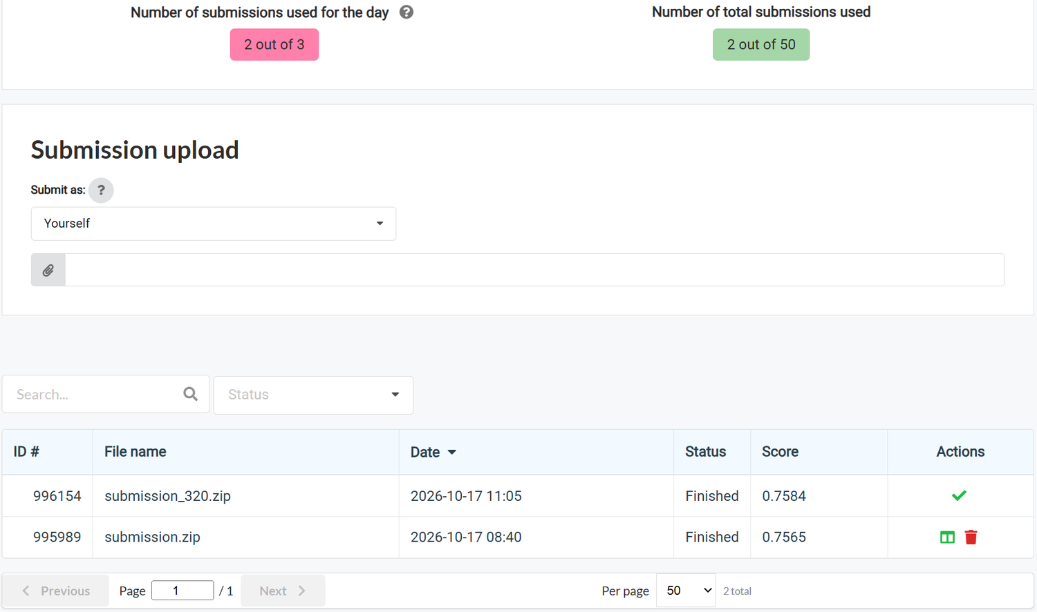
Figure 2. Top of the Track 1 test leaderboard (columns: Avg, mA, Label F1, Inst. Acc, Inst. Prec, Inst. Rec, Inst. F1).
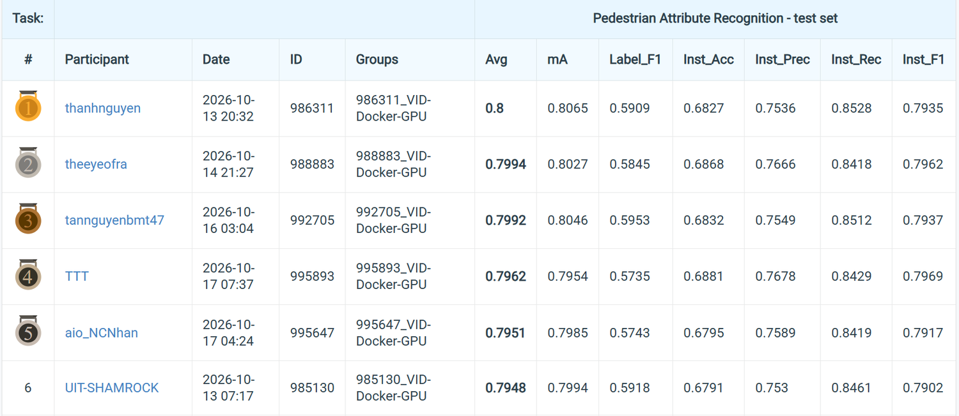
Figure 3. Our Run 1 (adinafraz, ID 995989) on the leaderboard at rank 41, same columns as Figure 2.
